Unit 2 Good habits
The 1st period
一、教学内容
Unit 2 Good habits Story time
二、教学目标
1. 能正确理解、朗读课文并可以根据提示复述课文内容。
2. 能听懂、会读、会说单词: tidy, messy, habits, in order, finish always sleepy bedtime.
3. 能尝试根据所学短语和句型来描述自己的习惯。
4. 能初步根据提示写出好的习惯。
5. 能分清好坏习惯，并知道以好的习惯来要求自己，让自己拥有更多好的习惯。
三、教学重点
1. 能正确理解、朗读课文并可以根据提示复述课文内容。
2. 能听懂、会读、会说单词: tidy, messy, habits, in order, finish always sleepy bedtime.
3. 能尝试根据所学短语和句型来描述自己的习惯。
四、教学难点
1. 能正确理解、朗读课文并可以根据提示复述课文内容。
2.能尝试根据所学短语和句型来描述自己的习惯。
五、教学准备：
头饰，板书制作，PPT
六、教学过程
Step1 Warming-up
T: Let’s look what do we learn today. Show the learning aims.
T: Do you want to know me well?
Listen to my chant carefully. (初步感知新的短语词汇。)
Step2 Presentation
1. T: You know in my chant, I say, I get up early, never go to bed late. Think about: never go to bed late, means A or B? （show the pictures）
Read the new word并板书。
T: Do you get up early and go to bed early? I think we should go to bed early.
T: And I often put my things in order. I want to know do you often put your things in order.
S: Yes, I do. /No, I don’t.
T: Good .Because I often put my things in order, so I can keep my room clean and tidy.
Teach: clean and tidy = not messy.
2. Look at the four sentences. What are they about? They are about my habits. So today we’ll learn a new lesson, good habits. (揭示并带读课题)
出示图片录音引导学生问答。
3. T: You know a lot about my habits. Look, here comes Liu Tao and Wang Bing. What habits do they have? (请学生讨论)
T: First let’s read the choices together.
S:……
T: Now, let’s listen to the tape and try to find the answer.
Listen and answer:
4. T: You did a very job. But I think there are more habits in the story. Please read the test again and try to find them out.
5. T: Good. They have a lot of habits here. But what are the good habits? And what are the bad habits?
S: Talk about in groups. Then say the answer.
6. Reading time.
T: Let’s read the test please. Look at the signs here.（注意读音的降调符号，提示学生在肯定句和感叹句要用降调来读）
7. Listen to the tape, read it one by one.
8. Read it together.
9. Retell the story
Step3 Consolidation
1. Think and talk
T: Hello, class. We know Liu Tao has three good habits, and two bad habits. He wants to do better. Can you help him to change the bad habits?
(小组讨论然后介绍你知道的好的习惯)
2. Try to write.
T: You say a lot of things about good habits. Now let’s make a video to let all of us have more good habits.
Step 4 Homework
1. Review story time and retell the story.
2. Make a poster（海报）of the good habits.
3. Copy some important phrases and sentences
七、板书设计
Unit 2 Good habits
Wang Bing: Liu Tao:
get up early, never… listen to the teachers…
brush teeth… keep the room …
put things in order do homework late…
finish the homework… feel sleepy…

The 2nd period
一、教学内容：
Fun time & Grammar time
二、教学目标
1. 能够在句子中正确应用程度副词修饰动词。
2. 能够应用本课所学的句型“Do you ...”/”Yes, I do./No, I don’t.”进行问答。
3. 培养学生养成良好的学习习惯和生活习惯。
三、教学重点：
1. 能够在句子中正确应用程度副词修饰动词。
2. 能够应用本课所学的句型“Do you ...”/”Yes, I do./No, I don’t.”进行问答。
四、教学难点：
能够在句子中正确应用程度副词修饰动词。
五、教学准备：挂图，卡片
六、教学过程：
Step 1 Free talk
T: Do you get up early in the morning?
S: ...
T: That’s a good/bad habit!
T: I have some habits too, Can you ask me? (出示动作图片)
S: Do you have your meals in the morning?
T: Yes, I do. I always...
S: Do you read books?
T: Yes, I do. I usually....
S: Do you clean the room
T: Yes, I do. I sometimes...
T: I have some good habits but I have bad habits too. Look at my panda eyes, I always go to bed late at night, it is a bad habit, you should go to bed early.
Step 2 Presentation
T: As a good students, we should have good habits, let’s make a good habits proposal step by step.
1. Step 1 is how to ask others.
You know my habits, how about you? Let’s play a game. Who want to be my partner?
Fun time----(1) T: Pick one....
(2)S: pick one...
pair work
T: Now, it’s your turn, pick one picture from the envelope and practice in pairs!
Magic box----T: Good job, boys and girls, you can ask other about their habits. Let’s have a rest.
2. Wang Bing’s habits and Liu Tao’s habits
First, ask Ss to say about habits.
Here are some sentences for you, can you read them? Look, these words are subjects/adverb of frequency/verb/adverbial modifier. Do you understand?
Second, the teacher write down the sentences on the blackboard.
Third, circle the words: fast late early well …
总结：动词+副词的用法。
Step 3 Consolidation
1. Do a survey
T：Great, let’s do a survey. First, let’s make a survey form.
Here is an example, fill one word into the blank and make it a good habit.
S：early.
T: Can you read it
S: Go to bed early at night.
T：here is another form, can you fill this line with your group member
Let’s check together. The first one is early, please read it.
The first one is well, please read it
The first one is early, please read it
They are all good habits. Now, let’s do a survey.
Do you go to school early in the morning?(随机问一名学生)
S: Yes, I do. (将该学生姓名填入表格)
Do a survey in your groups with this form.
提示句型： Do you ... ? Yes, I do./no, I don’t.
T: Ok, time’s up, I am going to be the first one.(教师示范)....
It’s time for you, who want to tell us about your group members
S: ...
2. Make a good habits proposal
T: Let’s make a good habits proposal according to your group survey.
Here is my good habit proposal. Work in group to finish your good habits proposal. Here are some tips for you.
评价：
If everyone in your group says one sentence, you will get 3 stars.
If all the members in your group say together, you will get 2 stars.
If only group leader say, you will get 1 star.
Step 4 Homework
1. Think of some more good habits and share with your classmates.
2. Put up your good habit proposal in the classroom or at home.
3. Review the two parts and then copy the sentences in Grammar time.
七、板书设计：
Unit 2 Good Habits
A: Do you...?
B: Yes, I do. / No, I don’t.
always usually
often sometime

The 3rd period
一、教学内容：
Sound time & Cartoon Time
二、教学目标
1. 能理解并体会字母组合or在单词中的发音，并适当扩展不同的发音。
2. 能理解Cartoon time的内容并动手实践
3. 能意识到good habits的重要性并付诸于实际生活
三、教学重点：
1. 能锻炼运用英语及与他人合作的能力。
2. 能意识到good habits的重要性并付诸于实际生活。
四、教学难点：
1. 能锻炼运用英语及与他人合作的能力。
2. 能意识到good habits的重要性并付诸于实际生活。
五、教学准备：卡片，电脑，练习纸
六、教学过程：
Step 1 Preparation
1．Greeting and make a self-introduction
Show a picture of me and let Ss ask me questions about my English name, hobby, best friend, and favorite color.
2．Tina’s e-mail
My best friend Tina invited me and other friends to her house.
We should bring some presents. Encourage the Ss to get my apples and flowers for Tina.
Step 2 Presentation
1. Sound time
Challenge1: Reading.
Rule: You can get my flowers by reading the words correctly and well.
Let’s enjoy a rhyme about my favorite animal — horses.
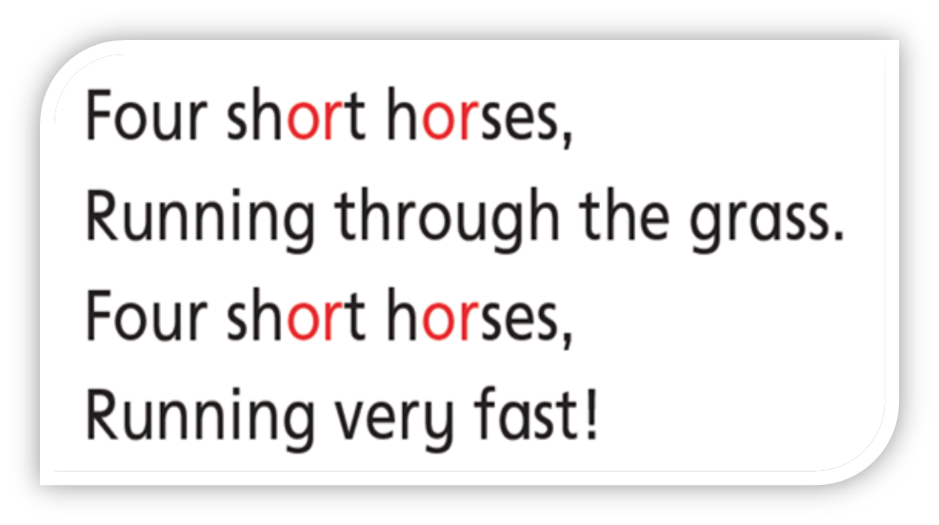
Let’s read some words in the rhyme and think the pronunciation of “or”.

Make a conclusion: or /ɔ:/
Let’s read the rhyme and words in four. (Flowers)
Challenge2: Picking apples.
Rule: You can get my apples by knowing the different pronunciations of “or”.
Find and discuss in 4. 摘下or 字母组合发/ɔ:/的苹果。


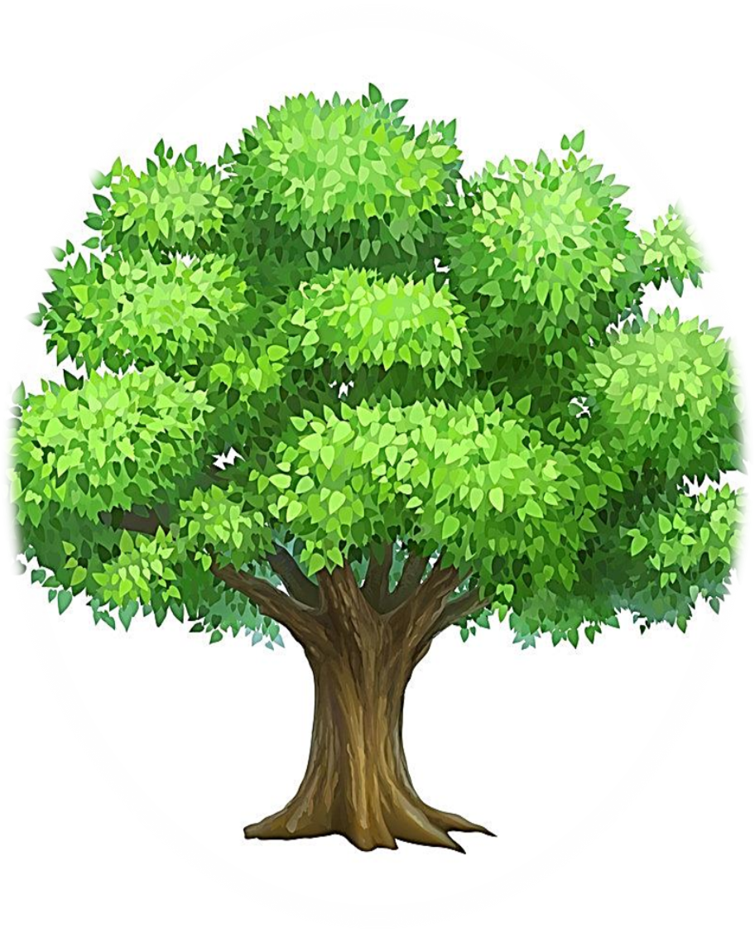
forty
morning
corn
doctor
world
actor
work
or
north
Apples: forty, morning, or, corn, pork, north，work, world, actor, doctor. Make a conclusion: “or” can not only be pronounced /ɔ:/, it can also be pronounced /ə/ and /ə:/.
2. Cartoon time
We got some apples and flowers for Tina, so let’s go into Tina’s house.
Miss Rabbit and Mr. Duck come to Tina’s house, too. They are talking. Let’s listen.
Q: How many rooms do they talk about? What are they?
S1: Three. They are a living room, Tina’s bedroom and Bobby’s bedroom.
Let’s go into Tina’s house and look at the rooms. Read and underline in 2.
Room | How is it?
A living room | big and clean
Tina’s bedroom | small but nice
Bobby’s bedroom | messy and dirty
3. Listen and repeat.
Step 3 Consolidation
1. Look and talk
Bobby’s bedroom is messy and dirty. (出示图片) Let’s help him and give him some suggestions.
We can say: We should…
Make a conclusion: We should put our things in order and keep good habits.
2. Write a diary.
Tip: Write down three suggestions.
Thursday, Dec.11th
Today we took some _____ and ______to Tina’s _____. Firstly, we ____ ____ the living room. It’s ____and _____. Then we went into____ bedroom. It’s _____ but ____. At last we went into _______ _______. It’s _____ and ____. There were a lot of _____ and ____ on the floor. Tina was very _____ because Bobby had ____ habits. She told Bobby that he should ____ everything ___ ____. I thought he should ____________ , _____________, and _______________.
Step 4 Homework
1. Read sound time and the story three times.
2. Tell the story to your parents.
七、板书设计
Unit 2 Good habits
sport horse
for short or /ɔ:/
We should put our things in order.

The 4th period
一、教学内容：
Checkout time， song time & ticking time
二、教学目标
1. I know some good habits and bad habits.
2. I can use “early”, “ late”, etc.
三、教学重难点：
1. I can use “early”, “late”, etc.
四、教学准备：
多媒体课件，单词图片
五、教学过程：
Step1 Warming- up
1. Greetings
First, let’s do some exercise together. Music! Let’s go.
Hello, boys and girls. Just now, we did some exercise. Doing exercise is a good habit.
2. Show the learning aims
Step2 Revision
T: Firstly, we are going to talk about good habits and bad habits of Wang Bing and Liu Tao.
(教师在黑板上板书)If you can’t remember, you can find some clues from these pictures. Now, please work in four.
Step3 Presentation and practice
1. We have known Liu Tao and Wang Bing’s good habits and bad habits very well. What about Su Hai and Su Yang’s habits? Please turn to P25. Let’s listen carefully and choose the right answer.
Listen and choose.
They have some good habits, but they have some bad habits too. Can you give some advice on these bad habits?
Ticking time
Let’s come to Ticking time. Who can read them?
T: Now please do ticking time by yourself.
T: You’ve done a good job. Now we can talk about good habits and
bad habits. Can you use “early”, “late”, etc? Let’s check.
Now, please turn to p24. Look at the pictures carefully and circle the right answer.
4. Please use the verbs and adverbs to make a sentence. Now work in four and try to make as many sentences as possible.
Step4 Homework
1. Give more advice on bad habits
2. Write about good habits and bad habits
六、板书设计
Unit 2 Good habits
Wang Bing(头饰) good habits bad habits
Liu Tao(头饰) gets up early does his homework late
never goes to bed late does not go to bed early
He finishes his homework before dinner
feels sleepy

The 5th period
一、教学内容：
本单元的复习及完成补充习题。
二、教学目标：
1. 复习本单元的相关词汇和句型
2. 完成相关练习
三、教学重难点:
能正确完成《补充习题》上面的练习。
四、教学准备：
练习纸
五、教学过程：
Step 1 Revision
1. Free talk
What habits does Wang Bing have? What habits does Liu Tao have?
As a good student, what habits should we have?
2. Have a dictation
1) have many good habits 2) never go to bed late
3) before bedtime 4) put his things in order
5) finish his homework before dinner
6) keep his room clean and tidy 7) do his homework late at night
8) feel sleepy 9) show you around our house
Step Two: Presentation and practice
完成补充习题。
题型：
A Listen and number.
B Listen and write.
C Look and say.
D Look, read and choose.
E Read and order.
F Read and judge.
a.部分题目也可以要求学生作听写任务，提高学生听说读写的语言综合运用能力。
b.题目选择，一些难的题目可以做为附加题，对于班级学习成绩比较优异的学生可以有这方面的要求。
c.在作业上可以分层作业，减轻后进生的学习负担，提高英语学习兴趣。
Step 3. Homework
1. Review this unit
2. Copy and recite the phrases and sentences underlined in this unit
六、板书设计
Unit 2 Good habits
gets up early does his homework late
never goes to bed late does not go to bed early
He finishes his homework before dinner feels sleepy

